Laboratory Report
999 – Headline of the lab assignment

Performed by:
First Name
Second Name

Introduction
In this section, the aim of the laboratory assignment is described. This description should comprise the purpose, and what actions have been planned, in a summary way. The reader must get an overview of what is physically connected and measured, as well as what learning outcomes are to be expected. There is a lot of information in the given lab instruction, and possibly in oral and/or written extra information given by the lab instructor, that can be used here in a rephrased way.
Exercise 1
It is sometimes (or often) a wise decision to divide the sections in the same headline styles as in the given lab instruction. As an example, one headline could be: ”The Characteristics of a Transformer” instead of ”Exercise 1” above.
The text in this section, according to the example mentioned above, would tell that you will study the characteristics of an AC transformer and give some examples of what is measured, like the transformer maximum ratings, the voltage conversion ratio, and the short-circuit resistance. After this you tell about the open-circuit and the short-circuit behavior of the transformer, in order to facilitate a theoretical understanding in the form of a model based on measured data. At last, you discuss how to measure the power losses at different loads and compare these with what would be theoretically expected from our produced model.

After Exercise 1, you describe Exercise 2 and Exercise 3, and so on, in the same manner.

Experimental
In this section, you describe, step by step, the execution of the exercises.
Exercise 1
There will be a chapter like this for every exercise of the laboratory assignment. Here, you describe the purpose of the exercise, and how the practical details will be handled.
Method
Here you show the circuit diagram of this exercise. Tell what you are going to measure, and what instruments are going to be used. For example, ”For the measurement of voltage, current, and power in a reactive load, the load will consist of a resistor and a coil in series, as in Fig. 1”.
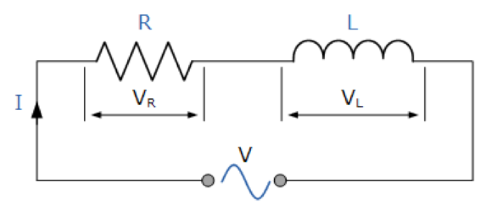
Figure 1. Reactive load consisting of a resistor and a coil in series. (The figure is taken from the lab instruction, Laboration 193 – Transformatorn och faskompensering.)
If you use any special measurement objects, these should also be described in this subsection. For example, a coil with an Iron core, used in, e.g., Lab 193 och 194, the data is shown in Table 1.
Table 1. Data of a coil, 1200 turns, with Iron core. Modeled as series circuit.
Frequency of operation (f) | 50 Hz
Series resistance (R_{S}) | 12,3 Ω
Series inductance (L_{S}) | 321,9 mH
An example, from another laboratory assignment, is to use a thermos flask filled with ice cubes and water, in order to get a stable temperature reference for measurements on temperature sensors.
In the Method subsection, it is convenient to give equations and formulas, which will be used in your calculations of data. Below is an example of how to write a numbered equation.
 | $$V=R∙I$$ | (1)
Insert a table using the menu “Insert” →”Table” and select one row and three columns. The very equation is put in the second column in a centered way, and the equation number in brackets is right adjusted in the third column. The first and the third columns should be of equal width (1-1.5 cm is usually an adequate width of the first and third columns).
Of course you should not have any borderlines in the table, so a correctly given equation should look like equation (2) below.
 | $$P=U∙I$$ | (2)
Results
Here your laboratory results are given. This means tables of measured data, and diagrams, which will contribute to the understanding and interpretation of measured results. You should also present results, which are produced using measured data and described equations and formulas. For example:
”The voltage V_{L} across the load is calculated using a load resistance, R = 120 Ω, and the measured current, I_{L}, in eq. (1)”.
N.B.
- You always refer to an equation with its number in brackets, like (1).
- All variables written in the body text should be formatted in Italic style, like “The voltage V_{L} across the load”.

The results may not consist only of figures. All figures, tables, and equations, should be referenced in the body text. Figure captions are placed below the referenced figures, and table captions are placed above the referenced tables. The body text should make sense of figures, tables, and equations. Do not expect the reader to guess! Tell the story in the body text.
When you refer to figures and/or tables it should be written like, “Data of the coil in Fig. 1 is taken from Table 1”.
You should also point out results that are unexpected or divergent. However, you should not get into any discussion about reasons for this in the Results subsection. This belongs to the next subsection, “Discussion” (or Conclusions). If tables become very long, or there are annoyingly many tables, these should be placed in an Appendix at the end of the report. Think of the reader!
Discussion (or Conclusions)
In this subsection, you discuss your results. This means to highlight results of particular interest, and make interpretations of measured data and produced results. Explain, for instance, that “the curve in Fig. 4 is associated with a slope of 3 (units), which is expected due to xyz”, or that it does not look like what was expected. Also try to explain (not make excuses) why some results did not turn out according to expectations. Do not use excuses like “The instruments were not working correctly”, “the devices/components/cables were bad”, or something else stupid like this. If an instrument was not yielding expected results, then explain why, and in what way, this is assumed. Maybe the measurement uncertainty of the instruments should be mentioned and accounted for. Tolerances of given component values may also influence the discussion. Try to be scientific!
Exercise 2
Method
Text describing the method of Exercise 2.
Results
Text showing results from the measurements and/or simulations in Exercise 2.
Discussion (or Conclusions)
Text discussing the results of Exercise 2.

