Turning a good RF source into an ideal source

Description:
An RF vector signal generator never generates spectrally pure excitation signals: on top of the desired spectral contributions additional unwanted frequency lines can be detected in the generated spectra. These unwanted components are due to the nonlinear contributions of the signal generator. When one wants to characterize the nonlinear behavior of a device, the observed nonlinear contributions in the output signals of the device, should be exclusively generated by the device itself and not by the signal generator. Hence, pure excitation signals are mandatory.
Recently a method has been developed to digital pre-distort the signal generator by means of parametric frequency-dependent modeling of the inverse of the nonlinear artifacts, including artifacts from in-phase (I) and quadrature (Q) modulation, leakage from the local oscillator (LO), and power ampliﬁer.
The goal of this master thesis is to extend this method by:
- Replacing the proposed finite impulse response (FIR) filters by infinite impulse response (IIR) filters to ensure maximal flexibility and a decrease in the number of estimated parameters.
- Taking into account the measurement noise. This is necessary since the input signal of the pre-distorter is now wrongly considered to be exact.
This master thesis allows you to get insight in arbitrary waveform generator, measurement techniques and signal processing as well as state-of-the-art digital pre-distortion techniques.

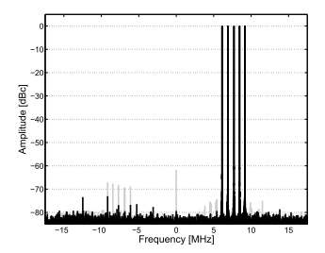
Illustration 1: Unwanted spectral lines (gray) and corrected spectrum (black)

Promotor 1
Name: Prof. Niclas Björsell (HIG, Sweden)
e-mail: niclas.bjorsell@hig.se

Promotor 2
Name: Prof. Wendy Van Moer (VUB, Belgium)
e-mail: wendy.vanmoer@vub.ac.be

Website of the research group: https://www.hig.se/Organisation/Institut-centrumbildningar/Radio-center-Gavle/Research.html, http://wwwtw.vub.ac.be/elec/

