Developing a low-cost directional coupler

Description:
A good high-frequency measurement instrument, such as a vector network analyzer, is nothing without a good directional coupler. A directional coupler separates signals based on the direction of signal propagation. Directional couplers are passive devices used in the field of radio technology by using two transmission lines set close enough together so that energy passing through is coupled to the other. These couplers are used to unequally split the signal flowing in the mainline and pass the signal that flows in the opposite direction.
The purpose of this master thesis is to build your own directional coupler based on microstrip technology. Different lay-outs can be considered and tested. Their performance will be compared and an optimal solution presented that satisfies the needs of low-cost and high performance. During this thesis you will gain a lot of inside in microwave theory and practical development.

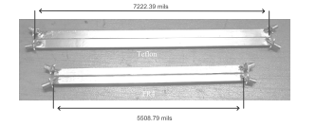

Illustration 1: Microstrip directional coupler

Link to webpage or article related to the subject (optional):
- http://www.home.agilent.com/upload/cmc_upload/All/Direct_CouplerOverview.pdfAgilent

Promotor 1
Name: Prof. Niclas Björsell (HIG, Sweden)
e-mail: niclas.bjorsell@hig.se

Promotor 2
Name: Prof. Wendy Van Moer (VUB, Belgium)
e-mail: wendy.vanmoer@vub.ac.be

Website of the research group: https://www.hig.se/Organisation/Institut-centrumbildningar/Radio-center-Gavle/Research.html, http://wwwtw.vub.ac.be/elec/

